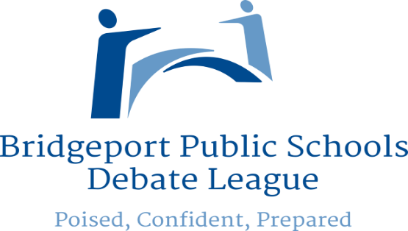

Celebrating 10 years of Parliamentary Debate

Congratulations

Discovery Magnet
Akhil Mannava & Philip Brockenberry

Winners
Inaugural
Veterans Day Debate

Runners up
Jetti Tisdale
Kayla Noel & Naomi Grey

